## Aditya Engineering College (A) :: Surampalem Project Review Committee

**AY 2022-23**

## Department of Electronics and Communication Engineering

**A Major Project on**

## BUS IDENTITY DETECTION USING IOT

***by***

|  |  |
| --- | --- |
| **VENKATA NAGA NANDIKESH KALEPU** | **20A95A0422** |
| **GREESHMANTH PYLA**  **RAVEENDRA REDDY NANDIKA** | **20A95A0420**  **20A95A0423** |
|  |  |

#### Batch No: D02

***Under the esteemed guidance of***

**Mr. S. Jagadeesh**

**Associate Professor**

# Abstract

Among all the fast-growing technologies, IoT and Machine Learning plays a key role. Without human intervention we can perform all the actions by using these technologies. We can connect everything by using IoT technology and make it smart and convenient. It makes human life easier and comfortable. By using these technologies, we can also detect whether the food that we are taking is fresh or not.

In these day’s food poison and food spoilage has become one of the major problems, as consuming spoiled food leads to harmful diseases like diarrhea and vomiting's. So many methods are implementing in the market to know the freshness of the food item like Artificial Intelligence approach, MIT research. etc. But, If the spoilage happened internally, those methods doesn’t give appropriate results. So, to overcome those disadvantages, we are using some sensors to detect the oxygen and ammonia levels of the food item that we want to take and by comparing those levels with predefined values, we can predict whether the food item is spoiled or not. By applying Machine Learning to this model, we can get better and accurate results.

**Project Title Submission of B.Tech VII semester**

Department of Electronics & Communication Engineering

**Guide Name:** Mrs. S. JAGADEESH **Academic Year :** 2022-23

**Batch No :** D02 **Date** :29/10/2022

|  |  |  |  |  |  |  |  |  |
| --- | --- | --- | --- | --- | --- | --- | --- | --- |
| **Type of The Project**  (Application Based / Product Based/ Simulation  / Research / Other, if any) | **Project Domain/Proje ct Identification** | **Abstract** | **Suggestions given by the Guide** | **PO/PSO’s**  **Addressed** | | | | **Remarks (Accepte d/ Rejected**  **)** |
| Research | IOT |  | Suggested | PO 1 | 3 | |  |  |
| based |  |  | to install |  |
| PO 2  PO 3  PO 4  PO 5  PO 6  PO 7  PO 8  PO 9  PO 10  PO 11  PO 12 | | 3  3  3  3  2  1  1  1  2  2  1 |  |
|  |  |  | MATLAB |  |
|  |  |  | 2021b and |  |
|  |  |  | initiate |  |
|  |  |  | coding of |  |
|  |  |  | the work. |  |
|  |  |  |  |  |
|  |  |  | Suggested to |  |
|  |  |  | download |  |
|  |  |  | quality recent |  |
|  |  |  | research |  |
|  |  |  | articles | Accepted |
|  |  |  | related to |  |
|  |  |  | multi model |  |
|  |  |  | medical |  |
|  |  |  | image fusion |  |
|  |  |  |  |  |
|  |  |  | Suggested to |  |
|  |  |  | summarize |  |
|  |  |  | the articles |  |
|  |  |  | based on the |  |
|  |  |  | methodology, |  |
|  |  |  | Performance |  |
|  |  |  | metrics, |  |
|  |  |  | advantages |  |
|  |  |  | and |  |
|  |  |  | limitations. |  |

#### Members :

1. K.V.N. Nandikesh 20A95A0422
2. P. Greeshmanth 20A95A0420
3. N. Raveendra Reddy 20A95A0423

#### Signature of Project Guide

**COs mapped in the Cycle I of Major Projects**

#### The following are the course outcomes (COs) mapped with the progress of the respective project,

|  |  |  |
| --- | --- | --- |
|  | **Course Outcome** | **Tentative mapping with PO** |
| **CO1** | **Identify a real life / engineering problem** | **(PO1)** |
| **CO2** | **Perform extensive investigation with prior knowledge** | **(PO2)** |
| **CO3** | **Interpret problem formulation and solution through**  **critical thinking** | **(PO2)** |
| **CO4** | **Develop the work plan, schedule and estimate the cost** | **(PO11)** |
| **CO5** | **Identify the resources required to initiate project work** | **(PO11)** |

**Signatures of Members :** Batch D02

1. K.V.N. Nandikesh (20A95A0422)
2. P. Greeshmanth (20A95A0420)
3. N. Raveendra Reddy (20A95A0423)

**Signature of Project Guide**

A Project Report on

## BUS IDENTITY DETECTION USING IOT

### Submitted in partial fulfillment of the requirements for the award of the degree

***of***

## Bachelor of Technology

**by**

#### VENKATA NAGA NANDIEKSH KALEPU Regd. No.: 20A95A0422 GREESHMANTH PYLA Regd. No.: 20A95A0420

**RAVEENDRA REDDY NANDIKA Regd. No.: 20A95A0423**

Under the Esteemed Guidance of

Mr. S.JAGADEESH,

Associate Professor



DEPARTMENT OF ELETRONICS AND COMMUNICATION ENGINEERING

**ADITYA ENGINEERING COLLEGE**

(An Autonomous Institution)

(Affiliated to JNTUK, Approved by AICTE & accredited by NAAC with ‘A’ Grade Recognized by

UGC under the sections 2(f) & 12(B) of the UGC act 1956) Surampalem-533 437

**2019-23**

**ADITYA ENGINEERING COLLEGE**

**An Autonomous Institution**

### Affiliated to JNTUK, Kakinada

(Approved by AICTE & Accredited by NAAC with ‘A’ Grade.)

## DEPARTMENT OF ELECTRONICS & COMMUNICATION ENGINEERING



***Certificate***

## This is to certify that the project report entitled “BUS IDENTITY DETECTION USING IOT” being submitted by

#### VENKATA NAGA NANDIKESH KALEPU Regd. No.: 20A95A0422

#### GREESHMANTH PYLA Regd. No.: 20A95A0420

**RAVEENDRA REDDY NANDIKA Regd. No.: 20A95A0423**

for the partial fulfillment of the requirements for the degree of **Bachelor of Technology** in Department of Electronics & Communication Engineering of Aditya Engineering College to Jawaharlal Nehru Technological University, Kakinada is a record of bonafide work carried out by them under the guidance and supervision during academic year of 2022-23.

#### Project Guide Head of the Department

Mr. S Jagadeesh Mr V. Satyanarayana

Associate Professor Professor & HOD

# DECLARATION

We hereby declare that the project “**BUS IDENTITY DETECTION USING IOT**” has been carried out by me this work has been submitted to Aditya Engineering College (A), Surampalem, affiliated to Jawaharlal Nehru Technological University, Kakinada in partial fulfillment of the requirements for the award of degree of Bachelor of Technology.

We further declare that this project work has not been submitted in full or part forthe award of any other degree of this on any other educational institutions.

#### VENKATA NAGA NANDIKESH KALEPU Regd. No.: 20A95A0422 GREESHMANTH PYLA Regd. No.: 20A95A0420

**RAVEENDRA REDDY N Regd. No.: 20A95A0423**

# ACKNOWLEDGEMENT

We would like to express gratitude of my guide **Mr. S. Jagadeesh, Associate Professor, Department of ECE,** Aditya Engineering College, Surampalem. His wide knowledge and logical way of thinking has made a deep impression on me. His encouragement and deep guidance has provided the basis for this project. His support and valuable suggestions are vital for the successful completion for this project.

We would like to convey my heartfelt gratitude to our Head of the Department **Mr. V. Satyanarayana, Associate Professor** for motivational guidance throughout the project work. Under his readiness for meeting at all times, educative explanation and inputs, anxiety as well as support even through realistic possessions has been tremendously helpful.

Our sincere gratitude to **Dr. M. SREENIVASA REDDY,** Principal of Aditya Engineering College. Whose emphasis for excellence kept me focused on to my project and helped me to complete it on time. We thank him for providing the necessary resource and facilities to carry out this project in time.

We would like to extent my thanks to all **teaching and non-teaching** staff of Aditya Engineering College for their support during my project work. We would like to articulate my special thankfulness to my acquaintance at the ECE for their priceless suggestions and to my family for their great support and continuous encouragement throughout this course.

#### VENKATA NAGA NANDIKESH KALEPU Regd. No.: 20A95A0422 GREESHMANTH PYLA Regd. No.: 20A95A0420

**RAVEENDRA REDDY NANDIKA Regd. No.: 20A95A0423**

# ABSTRACT

Among all the fast-growing technologies, IoT plays a key role. Without human intervention we can perform all the actions by using IOT. We can connect everything by using IoT technology and make it smart and convenient. It makes human life easier and comfortable. By using this technology, we can also detect the student’s whether the student have access to bus facility or not.

Therefore, in this project we are going to implement a advanced system using QR code scanning system. Automated student ID had image capturing facility. QR code is attached into ID card and student personal details can be found by scanning the QR code we can get the details of the students whether the student has the bus facility are not can be notified by using this bus identity detection system.

# CONTENTS

## PAGE NO

List of Figures i

List of Tables ii

Nomenclature iii

1. INTRODUCTION
   1. Introduction 1
   2. Objective of the Project 2
   3. Existing Methods 2
   4. Organization of the Report 6
2. LITERATURE SURVEY 8
3. ARCHITECTURE OF PROPOSED SYSTEM 10
4. HARDWARE/SOFTWARE DESCRIPTION 12
   1. Arduino Hardware 12
   2. Basic concepts of GPS 12
   3. Position calculation introduction 13
   4. GPS Structure 15
   5. LCD (Liquid Crystal Display) 18
   6. Transformers 23

4.7 ESP8266 29

REFERENCES 46

# LIST OF FIGURES

## Figure No. Figure Name Page No.

* 1. Pie Chart Showing Reasons for Road Accidents 02
  2. Block Diagram of Cloud Technology 03
  3. Output of the Technology 06
  4. Block Diagram of Arduino UNO 10
  5. Circuit Diagram of Arduino UNO 11
  6. GPS and Vibrator Sensor 12
  7. Two Spheres Surfaces Intersecting in a Circle 13
  8. Surface of Sphere Intersecting a Circle at two Points 14
  9. NMEA Input 15
  10. Schematic Diagram of LCD 20
  11. Power Supply for LCD 23
  12. Pin Diagram of 1x16 lines LCD 23
  13. Diode 24
  14. Half-wave Rectifier 25
  15. Full-wave Rectifier 26
  16. Capacitor Filter 27
  17. Focused Tapped Full-wave Rectifier with a Capacitor Filter 27
  18. Regulator 29

4.14 ESP8266 29

4.15 ESP8266 ESP-01 30

* 1. Pin Description of ESP8266 ESP-01 Module 31
  2. ESP8266 Arduino Interface 32
  3. Reference Image For Circuit Diagram 33
  4. Downloading the Rduino IDE 36
  5. Arduino Software Showing Toolbar 39
  6. Software Showing File Bar 41
  7. Output Prototype 42
  8. Map showing Vehicle location 43

ii

|  |  |  |
| --- | --- | --- |
| **Table No.** | **Name of the Table** | **Page No.** |
| 4.1 | 16x2 Alphanumeric LCD Module Specifications | 21 |
| 4.2 | Address Location for a 1x16 line LCD | 22 |

|  |  |
| --- | --- |
| IOT LED USB  DIP | Internet Of Things Light Emiting Diode Universal Serial Bus  Dual-in-line package |
| IDE | Integrated Development Environment |
| LPT | Line Print Terminal |
| GPS | Global Positioning System |
| GSM | Globa System for Mobile Communication |
| NMEA | National Marine Electronics Association |
| RTE | Run-Time Environment |
| WPL | Windows Play List |
| RMC | Relimate Connector |
| GSA | General Service Administration |
| GSV | Geostationary Servicing Vehicle |
| GGA | Global Positioning System Fix Data |
| WPL | Way-Point Location |
| RMB | Recommended Minimum Navigation Information |
| X-TE | X-Ray Timing Explorer |
| LCD | Light Crystal Display |

# CHAPTER-1 INTRODUCTION

## Introduction

We use cloud not exclusively to store information yet additionally for information review, gathering, representation. The vital highlights of cloud contain on-request administration development, save pooling and jumping. Internet of Things (IOT) impliescollaborate of gadgets with one another over the web. A few utilizations of IOT are Smart energy, smart city wellbeing checking framework. In IOT information is impartedfrom sensors and they can be kept and inspected by fluctuated IOT stages like Blynk, Thinger, Thing talk. In the current condition no short of what one unmistakable in the family has a vehicle. In the current age everybody nature is modifying with respect to time, and they burn-through to expansive their works in mannered time, so the necessity to boundless the work as ruffian as conceivable, since of that inclination they aspiration the vehicles exceptionally quick taking a chance with their lives to finish their work result to the expense of their life’s. Perhaps the most viable innovations in this moving world is IOT. IOT marks about the installed gadgets which are join with the web. IOT (Internet of Things) incorporates gadgets like sensors, actuators, engines and so forth theframework is utilized as an enemy of robbery framework in transport frameworks, public vehicles.

## Advantages

* + - 1. Proposed security system is most secured system as compared to other systems.
    - 2. It can be accommodated in all the vehicles and easy to use. This also provides a more security for the vehicle
    - 3. Low hard ware area overhead
    - 4. Low cost

The above advantages can be done when the vehicle is in coverage area.

## Applications

* + - 1. At transport stations.
    - 2. School or College attendance.

## OBJECTIVE OF THE PROJECT

It chooses the fundamental of another system and analyze on thing and advantage need, which is needed for the structure. The thing fundamental joins information and yield necessities it gives the requirements in term of commitment to make the necessary yield. The resource necessities describe to bring everything together about the item and hardware that are relied upon to accomplish the necessary handiness.

## EXISTING METHOD

In the present methodology there are using barcode on the student id cards for gathering students information. To identify whether a student have bus service or not it is done by a handwritten id card or marking something on id card to identify as a bus service is permitted to that student.

1. Hardware Requirements
   * Raspberry pi-4 model B.
   * Raspberry camera module.
   * NEO-6M GPS Module.
   * 16x2 LCD display.

B. Software Requirements

* Python IDE

#### PROJECT DESCRIPTION

1. Working with L80 GPS

L80 GPS module with an inserted fix radio wire (15mmx15mmx4mm) and LNA brings elite of MTK situating motor to the modern applications. It can accomplish the business most elevated amount of affectability, exactness and TTFF with the least power utilization in a little impression without lead bundle. With 66 look stations and 22 synchronous following stations, it secures and tracks satellites in the most brief time even at indoorflag level. The installed streak memory gives ability to clients to store some helpful route information and takes into consideration future updates.

1. Ds18b20 Temperature Sensor

This sensor is known as a One-Wire advanced temperature sensor. The one-wire alludes to the route in which you converse with the sensor and get data from it. This "family" of sensors uses a particular convention for how you get data from it. This implies we require some extraordinary libraries to add to the ways our Particle gadget can connect with sensors.

* + - One-Wire library
    - Dallas Temperature control library

You'll have to download both from GitHub and duplicate the

.cop and .h records from the firmware organizer to your venture envelope.

The sensor itself is truly simple to wire up. You'll notice is has three pins - one for power, one for ground and one for information (we read from this). We wire the computerized flag stick to an advanced stick on the Particle board.

1. Vibration Detection

The Vibration module taking into account the vibration sensor SW-420 and Comparator LM393 to distinguish if there is any vibration that past the edge. The edge can be adjusted by the on-board potentiometer. Exactly when this no vibration, this module yield reasoning LOW the banner shows LED light, and the opposite way around.

1. DESP 8266 Working

ESP8266 is a great, ease Wi-Fi module suitable for including Wi-Fi usefulness to a modern microcontroller increase with the aid of a UART serial association. The module microcontroller may even be reinvented to move approximately as an unbiased Wi-Fi associated device-simply consist of control!

The part summary is critical and joins:

* + - 802.11 B/G/N Convention
    - Wi-Fi Direct (P2P), sensitive AP

1. Building Graphical User Interface (GUI)

There are three stages associated with building a Visual Basic application:

1. Draw the UI
2. Assign properties to controls
3. Attach code to controls.

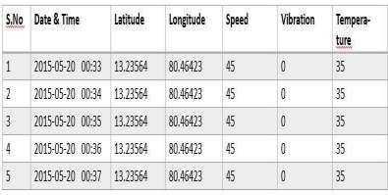

1. OUTPUT

#### Fig 1.3 Output of the Technology

The above showing the results from webpage which were taken from different sensors. The output is monitored continuously, giving the date and time along with location and other necessary values.

## Organization of the Thesis:

The project is organized as follows:

#### Chapter-1:

This explains about objective of the project and existing methods.

#### Chapter-2:

Literature Survey regarding implementation of Efficient Vehicle Monitoring and Alerting Using Secured IOT.

#### Chapter-3:

It presents a brief description of block diagram and circuit diagram of Arduino UNO.

#### Chapter-4:

It gives overview of hardware components and its working.

#### Chapter-5:

This explains about software implementation of Arduino IDE and resources used in this project.

#### Chapter-6:

This gives output prototype using Blynk app and vehicle location can be traced.

#### Chapter-7:

This explains about conclusion and future scope.

# CHAPTER-2 LITERATURE SURVEY

## 2.1 Literature Review

In the part of literature survey first consider the research papers for project to implement the vehicle monitoring and alerting using secured IOT.

#### Research Paper – 1:-

Md. Sanaul Haque and Richard Dybowski. They proposed a QR code based id card generation instead of manual handwritten id cards. This will gone through a four steps i)installation ii)Software user interface iii)Starting up screen iv) Capturing the student’s id card.

#### Research Paper – 2:-

Anusha impelled a system utilizing LPC2148 and the system has sorts like putting away in the data set. The exertion includes GPS,GSM modules. The sanction additionally distinguishes Alcohol utilization and Engine Temperature, all the norms can be seen on the Web page. So wellbeing is given to the voyagers in the vehicle.

# CHAPTER- 3 ARCHITECTURE OF PROPOSED SYSTEM

With the headway in Internet of Things (IOT) every gadget can be seen from web and produce information for different examinations. Late reports show the capacity of IOT in various applications like medical care, modern area and government areas. Our work is to utilize IOT for the vehicle condition observing i.e., concerning different variables including temperature inside the motor lodge, vibrations caused to the vehicle from outside sources, speed and area of the vehicle. All the above components can assume a significant part in identification of accident. Which is further valuable in shielding the person in question? Our principle point is to save the existences of accident casualties by sending the data with respect to the accident to the concerned people or systems. We make it conceivable by utilizing various sensors and a MCU to measure and send information to cloud. The sensors incorporates SW420 vibration identifier for distinguishing the effect levels, LM35 temperature sensor for detecting the temperature, NEO GPS module for finding the vehicle, ESP8266 module for associating the system with web lastly Arduino UNO microcontroller for handling. In this system Blynk application using for monitoring temperature, vehicle speed, and location of the vehicle. when accident occurred notification will come from Blynk application at the same time we can control the vehicle through Blynk application like apply breaks or shutdown the engine.

#### Block diagram:

ARDUINO

UNO

ESP 8266

GPS

VIBRATIO

BUZZER

MOTOR

TEMPERA

TURE SENSOR

POWER

16X2 LCD

**Fig 3.1 Block Diagram of Arduino UNO**

**w w w .T h e E n g in e e rin g P ro je c ts .com**

**O N**

**AN AL O G IN**

**R eset B T N**

**1121**

**ATME G A328P -P U**

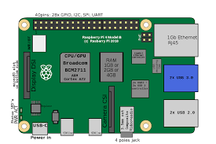

#### Fig 3.2 Circuit Diagram of Arduino UNO

Arduino UNO overview:

Arduino UNO is a surface mount breadboard embedded form with integrated USB. It is a complete breadboard well disposed. It has all that Diecimila/Duemilanove has (electrically) with more simple information pins and locally available +5v AREF jumper. Genuinely, it is missing force jack. The Nano is consequently sense and change to the higher likely wellspring of force, there is no requirement for the force select jumper.

Nano has the breadboard-capacity of the board and the Mini + USB with more modest impression than either, so clients have more breadboard space. It has a pin format that functions admirably with the Mini or the Basic Stamp (TX, RX< ATN, GND on one top, force and ground on the other). This new form 3.0 accompanies ATMEGA328 which offer seriously programming and information memory space. It is two layers. That make it simpler to hack and more moderate.

# CHAPTER-4 HARDWARE DEVELOPMENT

## Arduino Hardware

The Arduino is an amazing prototyping device for some, reasons, including its absence of a committed developer, its wide scope of a accessible libraries, and the effortlessness of its IDE. While we just got a light to squint in this task, you can anticipate significantly more later on. Take a stab at affiliating with shows, taking estimations, talking over the web, and perhaps in any event, working with AI!

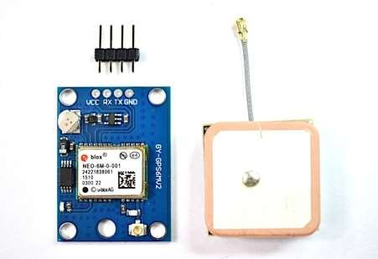

**Fig 4.1 GPS and Vibrator Sensor**

## Basic concept of GPS

A GPS collector ascertains its situation by exact planning the signs sent by GPS satellites high over the Earth. Each satellite constantly sends messages that incorporate.

* + - the time the message was sent
    - precise orbital data (the emphemeris)
    - the general system wellbeing and unpleasant circles of al GPS satellites(the chronological registry).

The collector utilizes the messages it gets to set up the travel season of each message and registers the distance to each satellite. These distances alongside the satellites areas are utilized with the conceivable guide of trilateration, contingent upon which calculation is utilized, to figure the situation of the collector. This position is then shown, may be with a moving guide show or scope and longitude; height data might be incorporated. Numerous GPS units show determined data like bearing and speed, determined from position changes.

Three satellites may appear enough to settle for position since space has three measurements and a situation close to the Earth’s surface can be expected. Notwithstanding, even an exceptionally little clock blunder duplicated by the enormous speed of light – the speed at which satellite signs create – brings about a huge positional mistake. Consequently beneficiaries utilize at least four satellites to settle for the recipient’s area and time. The precisely processed time is successfully covered up by most GPS applications, which utilize just the area. A couple of particular GPS applications, which utilize just the area. A couple of particular GPS applications do anyway utilize the time; these incorporate time move, traffic light planning, and synchronization of mobile phone base stations.

Albeit four satellites are needed for typical activity, less apply in exceptional cases. In the event that one variable is as of now known, a recipient can decide its position utilizing just three satellites. For instance, a boat or airplane may have known height. A few GPS recipients may utilize extra hints or presumptions, (for example, reusing the last known elevation, dead retribution, inertial route, or including data from the vehicle PC) to give a lessexact (debased) position when less than four satellites are noticeable.

## Position calculation introduction

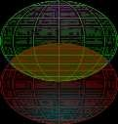



#### Fig 4.2 Two sphere surfaces intersecting in a circle

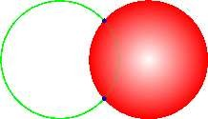



**Fig 4.3 Surface of sphere intersecting a circle (not a solid disk) at two points**

To give an early on portrayal pf how a GPS recipient functions, mistake impacts are conceded to a later segment. Utilizing messages got from at least four obvious satellites, a GPS recipient can decide the occasions sent and afterward the satellite positions impart to these occasions sent. The x, y and z parts of position, and the time sent, are named as where the addendum l is the satellite number and has the worth 1,2,3 or 4. Knowing the showed time the message was gotten, the GPS collector could process the travel season of the message as, if would be equivalent to address gathering time. A pseudo reach, would be the voyaging distance of the message, accepting it went at the speed of light, c.

A satellite’s position and pseudo reach characterize a circle, fixated on the satellite, with span equivalent to the pseudo reach. The situation of the beneficiary is some place on the outside of this circle. In this way with four satellites, the demonstrated situation of the GPS recipient is at or close to the combination of the surfaces of four circles. In the ideal instance of no mistakes, the GPS collector would be at an exact convergence of the four surfaces.

In the event that the surfaces of two circles converge at more than one point, they cross all around. The article trilateration shows this numerically. A figure, Two Sphere Surfaces Intersecting in a Circle, is appeared in the figure. The distance between these two focuses is the measurement of the circle of convergence. The convergence of a thirdcircular surface with the initial two will be its crossing point with that circle; much of the time of pragmatic premium, this implies they meet at two points. Another figure, Surface ofSphere Intersecting a Circle (not a strong plate) at Two Points, delineates the convergence. The two convergences are set apart with dabs. Again the article trilateration obviously shows this numerically.

For cars and other close earth vehicles, the right situation of the GPS beneficiary is the convergence nearest to the Earth’s surface. For space vehicles, the crossing point farthest from Earth might be the right one.

The right situation for the GPS recipient is likewise the crossing point nearest to the outside of the circle comparing to the fourth satellite.

## GPS STRUCTURE

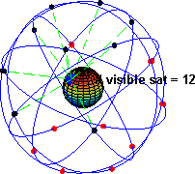

#### Fig 4.4 NMEA input

A few units likewise uphold a NMEA input mode. While not very numerousprojects uphold this mode it gives an organize approach to refresh or add way point and course information. Note that there is no handshaking or orders in NMEA mode so you simply send the information in the right sentence and the unit will acknowledge the information in the right sentence and the unit will acknowledge the information and add or overwrite the data in memory. IN the event that the information isn’t in the right organization it will just be overlooked. A carriage return/line feed grouping is required. In the event that the waypoint name is a similar you will overwrite existing information yet no admonition will be given. The sentence development is indistinguishable from what the unit downloads so you can, for instance, catch a WPL sentence from one unit and afterward send that equivalent sentence to another unit however be cautious if the two units uphold waypoint names of various lengths since the accepting unit may shorten the name and overwrite a waypoint accidently. In the event that you make a sentence without any preparation you ought to make a right checksum. Be certain you know and have set you unit to the right

datum. Numerous units uphold the contribution of WPL sentences and a couple of help RTE too.

On NMEA input the recipient stores data dependent on deciphering the actual sentence. While a few recipients acknowledge standard NMEA input this must be utilized to refresh a waypoint or comparative errand and not to send an order to the unit. Restrictive info sentences could be utilized to send orders. Since the Magellan transfer and download upkeep convention depends on NMEA sentences they uphold an altered WPL message that adds remarks altitude and symbol information.

Some marine units may acknowledge contribution for cautions, for example, profound or shallow water dependent on the DPT sentence or MTW to peruse the water. For instance the Garmin Map76 upholds DPT, MTW(temperature) and VHW(speed) input sentences. Different units may utilize NMEA contribution to give instatement information through exclusive sentences, or to choose which NMEA sentences to output.

The main NMEA sentences incorporate the GGA which gives the current Fix information, the RMC which gives the base GPS sentences data, and the GSA which gives the Satellite status information.

In the event that the tallness of geoid is feeling the loss of, the height ought to be suspect. Some non-standard executions report height concerning the ellipsoid as opposed to geoid elevation. A few units don’t report height concerning the ellipsoid opposed to geoid elevation. A few units don’t report negative heights by any stretch of the imagination. This is is the solitary sentence that reports elevation.

GSA-GPS DOP and dynamic satellites. This sentence gives subtleties in the idea of the fix. It incorporates the quantities of the satellites being utilized in the current arrangement and the DOP. DOP means that the impact of satellite math on the exactness of the fix. It is a unit less number where more modest is better. For 3D fixes utilizing 4 satellites a 1.0 would be viewed as an ideal number, anyway for over decided arrangements it is conceivable to see numbers beneath 1.0. There are contrasts in the manner the PRN’s are introduced which can impact the capacity of certain projects to show this information. For instance, in the model

appeared beneath there are 5 satellites in the arrangement and the invalid places that are not being utilized as a component of this arrangement. Different recipients may yield the entirety of the satellites utilized toward the start of the sentence with the invalid field all piled up toward the end. This distinction represents some satellite presentation programs not continually having the option to show the satellites being followed. A few units may show allsatellites that have register information regardless of their utilization as a feature of the arrangement however this is non-standard.

GSV-Satellites in View shows information about the satellites that the unit could possibly discover dependent on its review veil and chronological registry information. It additionally shows current capacity to follow this information. Note that one GSV sentence just can give information to up to 4 satellites and hence there may should be 3 sentences for the full data. It is sensible for the GSV sentence to contain a larger number of satellites than GGA may show since GSV may incorporate satellites that are not utilized as a component of the arrangement. It’s anything but a requirement that the GSV sentences all show up in succession. To try not to over-burden the information data transfer capacity a few recipients may put the different sentences in examples since sentence distinguishes which one it is.

The field called SNR (Signal to Noise Ratio) in the NMEA standard id frequently alluded to assign strength. SNR is a circuitous however more helpful worth that crude sign strength. It can go from 0 to 99 and has units of dB as indicated by the NMEA standard, however the different makers send various scopes of numbers with various beginning numbers so the actual qualities in a given GPS will generally show a distinction of around

25 to 35 between the most minimal and most noteworthy qualities, anyway 0 is an uncommon case and might be appeared on satellites that 35 between the least and most noteworthy qualities, anyway 0 is an extraordinary case and might be appeared on satellites that are in see yet not being followed in see yet not being followed.

GLL-Geographic Latitude and Longitude is an extra from Loran information and some old units may not send the time and information dynamic data on the off chance that they are imitating Loran information. On the off chance that a GPS is copying Loran information they may utilize LC Loran prefix rater than GP.

Collectors that don’t have an attractive deviation table implicit will invalid out the Magnetic track made great. Interpret of some Navigation Sentences.

WPL- Waypoint Location information gives important waypoint information. It is yield when exploring to demonstrate information about the objective and is some of the time upheld on contribution to rethink a waypoint area. Note that waypoint information as characterized in the standard doesn’t characterize elevation, remarks, or symbol information. At the point when all waypoints have been accounted for the RTE sentence is sent in the following informational collection. In any gathering of sentences, just a single WPL sentence, or an RTE sentence will be sent.

APB-Autopilot design B is sent by certain GPS collectors to permit them to be utilized to control an autopilot unit. This sentence is usually utilized via autopilots and contains route collector cautioning banner status, cross-track-mistake, waypoint appearance status, beginning bearing from source waypoint to the objective, persistent bearing from present situation to objective and prescribed going to direct to objective waypoint.

Magellan utilizes restrictive sentences to do the entirety of their waypoint and course upkeep. They utilize the MGN prefix for their sentences. This utilization is archived in their interface determination and won’t be rehashed here. In any case, they additionally send exclusive sentences to increase the GPS information actually like Garmin does.

## LCD (Liquid Crystal Display):

A liquid crystal display (LCD) is a dainty, level presentation gadget comprised of quite a few tone or monochrome pixels orchestrate before a light source or reflector. Every pixel comprises of a segment of fluid precious stone atoms suspended between two straight forward cathodes, and two polarizing channels, the tomahawks of extremity of which are opposite to one another. Without the fluid precious stones between them, light goingthrough one would be impeded by the other. The fluid precious stone curves the polarization of light entering one channel to permit it to go through the other.

A program should interface with the rest of the world utilizing information and yield gadgets that discuss straight forwardly with an individual. Quite possibly the most

well-known gadgets connected to a regulator is a LCD show. The absolute most regular LCDs associated with the regulators are 16x1, 16x2 and 20x2 showcases. This implies 16 characters for every line by 1 line 16 characters for each line by 2 lines and 20 characters for each line by 2 lines, separately.

Numerous microcontroller gadgets use ‘smart LCD’ presentations to yield visual data. LCD shows planned around LCD NT-C1611 module, are cheap, simple to utilize, and it is even conceivable to create a readout utilizing the 5x7 dabs in addition to cursor of the presentation. They have a standard ASCII set of characters and numerical images. For a 8- digit information transport, the presentation requires a +5V supply in addition to 10 I/O lines (RS RW D7 D6 D5 D4 D3 D2 D1 D0). For a 4-cycle information transport it just requires the inventory lines in addition to extra lines (RS RW D7 D6 D5 D4).At the point when the LCD show isn’t empowered, information lines are tri – state and they don’t meddle with the activity of the microcontroller.

#### Features:

1. Interface with either 4-bit or 8-bit microprocessor.
2. Display data RAM
3. 80x8 bits (80 characters).
4. Character generator ROM
5. 160 different 5 X7 dot-matrix character patterns.
6. Character generator RAM
7. 8 different user programmed 5X7 dot-matrix patterns.
8. Display data RAM and character generator RAM may be Accessed by the microprocessor.
9. Numerous instructions
10. Clear Display, Cursor Home, Display ON/OFF, Cursor ON/OFF, Blink Character, Cursor Shift, Display Shift.
11. Built-in reset circuit is triggered at power ON.
12. Built-in oscillator.

#### Description Of 16x2:

This is the first interfacing model for the Parallel Port. We will begin with something basic. This model doesn’t utilize the Bi-directional element found on more up to newer ports,

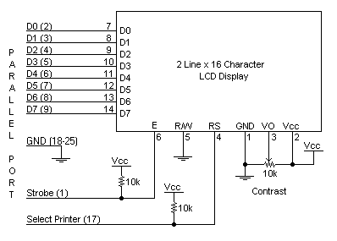

subsequently it should work with most, if no all Parallel Ports. It anyway doesn’t show the utilization of the Status Port as an input. So the thing would we say we are interfacing? A 16 Character x2 Line LCD Module to the Parallel Port. These LCD Modules are extremely regularly nowadays, and are very easy to work with, as all the rationale needed to run them is ready.

**Schematic Diagram:**

**Fig4.5 Schematic Diagram of LCD**

Above sis the very straight forward schematic. The LCD board’s Enable and Register is associated with the Control Port. The control Port is an open gatherer/open channel yield. While most Parallel Ports have inward draw up resistors, there are not many which don’t. In this way by coordinating the two 10k outside pull resistors, the circuit is more versatile for a more extensive scope of PCs, some of which may have no inward draw up resistors.

We put forth no attempt to put the Data transport into turn around bearing. Accordingly we hard wire the R/W line of the LCD board, into compose mode. This will cause no transport clashes on the data lines. Subsequently we can’t peruse back the LCD’s inward Busy Flag which advises us if the LCD has acknowledged and wrapped up handling the last guidance. This issue is overwhelmed by embedding known deferrals into our program.

The 10k Potentiometer controls the difference of the LCD board. Nothing extravagant here. Similarly as with every one of the model’s, I’ve left the force supply out. You can utilize a seat power supply set to 5v or utilize a locally available +5 controller. Recollect a couple of de-coupling capacitors, particularly in the event that you experience difficulty with the circuit working appropriately.

#### 16 x 2 Alphanumeric LCD Module Features:

* Intelligent, with built-in Hitachi HD44780 compatible LCD controller and RAM providing simple interfacing
* 61 x 15.8 mm viewing area
* 5 x 7 dot matrix format for 2.96 x 5.56 mm characters, plus cursor line
* Can display 224 different symbols
* Low power consumption (1 mA typical)
* Powerful command set and user-produced characters
* TTL and CMOS compatible
* Connector for standard 0.1-pitch pin headers

**Table 4.1 16 x 2 Alphanumeric LCD Module Specifications:**

|  |  |  |  |
| --- | --- | --- | --- |
| **in** | **Symbol** | **Level** | **Function** |
|  | VSS | - | Power, GND |
|  | VDD | - | Power, 5V |
|  | Vo | - | Power, for LCD Drive |
|  | RS | H/L | Register Select Signal H:DataInput  L: Instruction Input |

|  |  |  |  |
| --- | --- | --- | --- |
|  | R/W | H/L | H: Data Read (LCD->MPU)  L: Data Write (MPU->LCD) |
|  | E | H,H->L | Enable |
| -14 | DB0-  DB7 | H/L | Data Bus; Software selectable 4- or  8-bit mode |
| **5** | NC | - | **NOT CONNECTED** |
| 6 | NC | - | **NOT CONNECTED** |

#### FEATURES:

* + 5 x 8 dots with cursor
  + Built-in controller (KS 0066 or Equivalent)

• + 5V power supply (Also available for + 3V)

* + 1/16 duty cycle
  + B/L to be driven by pin 1, pin 2 or pin 15, pin 16 or A.K (LED)
* N.V. optional for + 3V power supply

#### Data can be placed at any location on the LCD. For 16×1 LCD, the address locations are:

**Table 4.2 Address locations for a 1x16 line LCD**

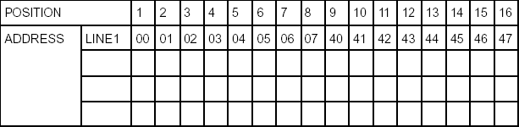

Indeed, even restricted to character based modules, there is as yet a wide assortment of shapes and sizes accessible. Line lengths of 8,16,20,24,32 and 40 characters are generally standard, in one, two and four line forms.

A few diverse LC advancements exists “ supertwist” types, for instance, offer Improved differentiation and survey point over the more established “curved nematic”types. A few modules are accessible with backdrop illumination, so they can be seen in faintly lit conditions. The backdrop illumination might be either “electro-iridescent”, requiring a high voltage inverter circuit, or basic LED light.

#### Power supply for LCD driving:

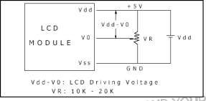

**Fig 4.6 Power supply for LCD PIN DESCRIPTION:**

Most LCDs with 1 controller has 14 Pins and LCDs with 2 controller has 16 Pins (two pins are extra in both for back-light LED connections).

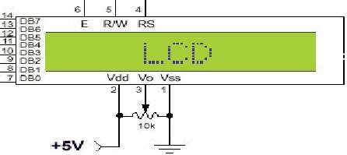

**Fig 4.7 Pin diagram of 1x16 lines LCD**

## TRANSFORMERS

By and large these Step-Up Transformers are utilized in ventures applications as it

were.

#### Turns Ratio and Voltage

The proportion of the quantity of turns on the essential and optional loops decides the proportion of the voltages,

[Equation]

where Vp is the essential (input) voltage, Vs is the auxiliary (yield) voltage, Np is the quantity of turns on the essential loop, and Ns is the quantity of turns on the optional curl.

#### Diodes:

Diodes permit power to stream just a single way. The bolt of the circuit image shows the heading wherein the current can stream. Diodes are the electrical rendition of a valve and early diodes were really called valves.

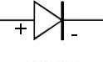

#### Fig 4.8 Diode

**Figure: Diode Symbol**

A diode is a gadget which just permits current to move through it one way. Toward this path, the diode is supposed to be ‘forward-one-sided’ and the solitary impact on the sign is that there will be a voltage loss of around 0.7V. The other way, the diode is supposed to be‘converse one-sided’ and no current will course through it.

#### Rectifier

The motivation behind a rectifier is to change over an AC waveform into a DC waveform (OR) Rectifier changes over AC current or voltages into DC current or voltage. There aretwo diverse correction circuits, known as ‘half wave’ and ‘full wave’ rectifiers. Both use segments called diodes to change over AC into DC.

#### The Half Wave Rectifier

The half-wave rectifier is the least difficult kind of rectifier since it just uses one diode, as demonstrated in figure

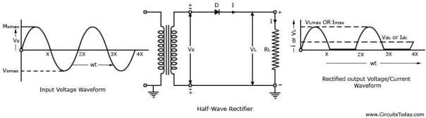

#### Figure 4.9 Half Wave Rectifier

Figure 2 shows the AC input waveform to this circuit and the subsequent yield. As should be obvious, when the AC input is positive, the diode is forward-one-sided and lets the current through. At the point when the AC input is negative, the diode is opposite one-sided and the diode doesn’t let any current through, which means the yield is 0V. Since there is a 0.7V voltage misfortune across the diode, the pinnacle yield voltage will be 0.7V not much as Vs.

While the yield of the half-wave rectifier is DC(it is all certain), it would not be appropriate as a force supply for a circuit. Initially, the yield voltage consistently fluctuates among 0V and Vs-)0.7V, and besides, for a fraction of the time there is no yield by any means.

#### The Full-Wave Rectifier

The circuit in figure tends to the second of these issues since at no time is the yield voltage 0V. This time four diodes are masterminded so both the positive and negative pieces of the AC waveform are changed over to DC. The subsequent waveform is appeared in figure.

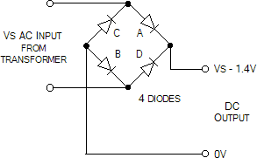

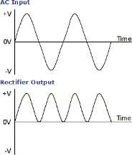

#### Figure 4.10 Full-Wave Rectification

At the point when the AC input is positive, diodes A and B are forward-one-sided, while diodes C and D are converse one-sided. At the point when the AC input is negative, the inverse is valid – diodes C and D are forward-one-sided, while diodes A and B are opposite one-sided.

While the full-wave rectifier is an enhancement for the half-wave rectifier, it’s yield actually isn’t reasonable as a force supply for most circuits since the yield voltage actually

changes among 0V and Vs-1.4V. Thus, in the event that you put 12V AC in, you will 10.6V DC out.

#### Capacitor Filter

The capacitor-input channel, likewise called “Pi” channel because of its shape that seems as though the Greek Letter pi, is a kind of electronic channel. Channel circuits are utilized to eliminate undesirable or undesired frequencies from a sign.

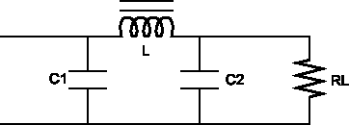

#### Figure 4.11 Capacitor Filter

A regular capacitor input channel comprises of a channel capacitor C1, associated across the rectifier yield, an inductor L, in arrangement and another channel capacitor associated across the heap.

1. The capacitor C1 offers low reactance to the AC part of the rectifier output while it offers endless reactance to the DC component. Accordingly the capacitor shunts an apparent measure of the AC part while the DC component proceeds with its excursion to the inductor L.
2. The inductor L offers high reactance to the AC component yet it offers very zero reactance to the DC part. Therefore the DC part moves through the inductor while the AC segment is impeded.
3. The capacitor C2 sidestep the AC segment which the inductor had neglected to obstruct. Accordingly just the DC part shows up across the heap RL.

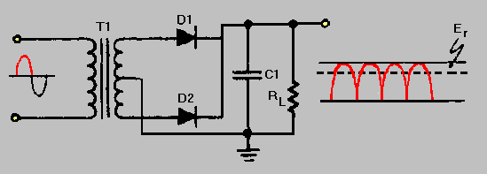

#### Figure 4.12 Focused Tapped Full-Wave Rectifier with a Capacitor Filter

**Voltage Regulator:**

A voltage controller is an electrical controller intended to consequently keep a steady voltage level. It might utilize an electromechanical instrument, or detached or dynamic electronic parts. Contingent upon the plan, it very well might be utilized to direct at least one AC or DC voltages. There are two kinds of controller are they.

* Positive Voltage Series (78xx) and
* Negative Voltage Series (79xx)

**78xx:** ‘78’ demonstrate the positive arrangement and ‘xx’ indicates the voltage rating. Assume 7805 produces the most extreme 5V. ‘05’ indicates the controller output is 5V.

**79xx:** ‘79’ show the negative arrangement and ‘xx’ indicates the voltage rating. Assume 7905 produces the most extreme -5V. ‘05’ indicates the controller output is -5v.

These controllers comprises the three pins there are

**Pin 1:** It is utilized for input pin.

**Pin 2:** This is ground pin for controller.

**Pin 3:** It is utilized for output pin. Through this pin we get the output.

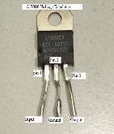

**Figure 4.13 Regulator**

## 4.7 ESP8266

#### ESP8266:

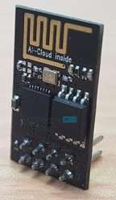In the event that you are into IOT (Internet of Things),you may have known about ESP8266 WI-FI Module. If not, don’t stress. This instructional exercise is tied in with beginning with ESP8266 WI-FI Module and how the ESP8266 Arduino pair can be utilized in your IOT Projects. In this way, prior to delving into the subtleties ofhow to interface the ESP8266 Arduino Pair, how about we begin with ESP8266 WI- FI Module first.

#### Fig 4.14 ESP8266

**ESP8266 ESP-01**

In this undertaking, we will utilize the Ai-Thinker’s ESP-01 Module. It comprises of 8pins and the accompanying picture shows the various components of the board.

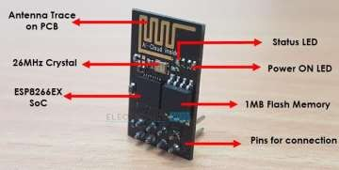

#### Fig 4.15 ESP8266 ESP-01

**What is ESP8266?**

ESP8266 (in fact ESP8266EX) is a WI-FI Module dependent on Cadence Tensilica L106 32- cycle MCU made by Express if Systems. The ESP8266 contains a completely useful WI-FI Stack and TCP/IP Stack that permits any Microcontroller to get associated with WI-FI Network.

With Software Development Kits (SDKs), you can straight forwardly program the ESP8266’s on-chip Microcontroller, without the requirement for an outside Microcontroller.

In view of the ESP8266 , a few outsider makers began fabricating custom sheets and one such producer is Ai-thinker. The primary board fabricated by Ai- Thinker is ESP-01 (which is a similar board utilized in this task) and it turned out to be very mainstream.

In view of the accomplishment of the ESP-01 Module, a few different modules like ESP-02, ESP-07, ESP-12 and so forth were delivered by Ai- Thinker. Every one of these sheets depend on ESP8266 however the primary distinction is the quantity of GPIO pins.

There are different modules like ESP-WROOM by Express if systems, Node MCU, We MOS, Spark Fun, ESP8266, and so forth

Going to the pin design, as referenced over, the ESP-01 module comprises 0f 8 oins and these pins are VCC, GND, TX, RX, RST, CH_PD, GPIO0 and GPIO2. The accompanying picture shows the pin outline of the ESP-01 Module.

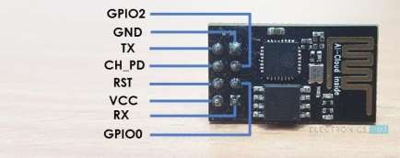

#### Fig 4.16 Pin Description of ESP8266 ESP-01 Module

**Pin Description:**

* **VCC:** It is the power pin through which 3.3V is provided.
* **GND:** It is the ground pin.
* **TX:** This pin is utilized to communicate sequential information to different gadgets.
* **RX:** The RX pin is utilized to get sequential information from different gadgets.
* **RST:** It is the Reset Pin and it is a functioning LOW pin.(ESP8266 will reset if the RST pin gets LOW sign.)
* **CH_PD:** This is the chip empower pin and it is a functioning HIGH pin. It is typically associated with 3.3V.
* **GPIO0**: The GPIO0 (General Purpose I/O) Pin has double capacities – one for typical GPIO Operation and other for empowering the Programming Mode of ESP8266.
* **GPIO2**: This is GPIO Pin.

**SIGNIFICANT NOTE**: The ESP8266 isn’t viable with 5V and the ESP-01 Module doen’t have any voltage controllers ready. Ensure that the power supply to the ESP8266 is 3.3V, ideally from a devoted power supply as opposed to taking it from the 3.3V Pin of the Arduino.

#### ESP8266 Arduino Interface

Prior to seeing the ESP8266 Arduino Interface, you need to know a couple of things about the ESP8266 Module. The ESP8266 WI-FI Module accompanies default firware which upholds AT orders.

In the wake of interfacing the ESP8266 WI-FI Module with Arduino and transferring our own program, the first firmware will be eradicated. We will find in a different venture on the most proficient method to interface ESP8266 Module for AT Commands and furthermore how to streak the first firmware utilizing Arduino.

Presently, we will perceive how to program ESP8266 utilizing Arduino and access its GPIO pins. To start with, we will see the circuit chart of the interface.

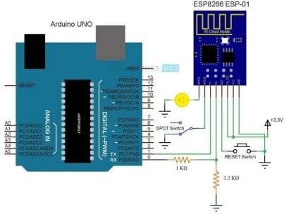

#### Fig 4.17 ESP8266 Arduino Interface

On the off chance that the ESP8266 Module in the circuit chart isn’t clear, the accompanying picture may help you. It is only an individual portrayal for circuit chart. You have effectively seen genuine pin outline in the past area.

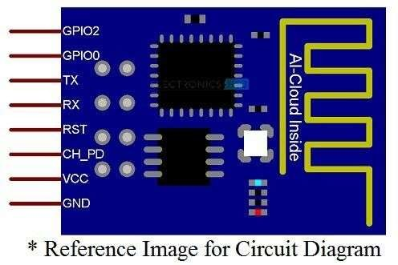

**Fig 4.18 Reference Image for Circuit Diagram**

# REFERENCES

1. ManaliShilimkar “Survey Paper on Vehicle Tracking System using GPS and Android”, International Journal of Advanced Research in Computer Engineering & Technology (IJARCET) Volume 3 Issue 11, November 2014
2. A Anusha “Vehicle Tracking and Monitoring System to Enhance the Safety and Security Driving Using IOT” 2017 International Conference on Recent Trends in Electrical, Electronics and Computing Technologies (ICRTEECT), July 2017
3. Mayuresh Desai “Internet of Things based vehicle monitoring system” 2017 Fourteenth International Conference on Wireless and Optical Communications Networks (WOCN) IEEE, Feb 2017.
4. Navod “Vehicle Monitoring, controlling and tracking System by using android application”, International Journal of Technical Research and Applications,Volume4, Isuue1
5. Prasanth “Advanced vehicle monitoring and tracking system based on Raspberry Pi”, 2015 IEEE 9th International Conference on Intelligent Systems and Control (ISCO).
6. Harum “Vehicle Detection and Tracking System IOT based”, International Research Journal of Engineering and Technology (IRJET),Volume-5,Issue-8.
7. Imteaj “Smart Vehicle Accident Detection and Alarming System Using a Smartphone”, conference: 2015 International Conference on Computer and Information Engineering (ICCIE),November 2015
8. Das “Vehicle accident prevent cum location and monitoring system”, 2017 8th Annual Industrial Automation and Electromechanical Engineering Conference (IEMECON),August 2017.
9. P. Verma and J. Bhatia, "Design and Development of GPSGSM based Tracking System with Google map based Monitoring," International Journal of Computer Science, Engineering and Applications (IJCSEA), vol. 3, no. 2,June 2013.
10. N Mangla, K Sushma, L Kumble, ” IPB-Implementation of Parallel Mining for Big Data”, Indian Journal of Science and Technology, 2016 11. T. Le-Tien and V. Phung-The, "Routing and Tracking System for Mobile Vehicles in Large Area," Fifth IEEE

International Symposium on Electronic Design, Test and Application, pp. 297-300, January 2010.

1. Wang wei, fan hanbo, traffic accident automatic detection and remote alarm device.
2. M.Rajendra Prasad, P.Aswani “An automated traffic accident detection and alarm device” International Journal of Technological Exploration and Learning (IJTEL) Volume 1 Issue 1 (August 2012).
3. Ms. Sarika B. Kale, Gajanan P. Dhok “Embedded system for intelligent ambulance and traffic control management International Journal of Computer and Electronics research” Volume 2, Issue 2, April 2013.
4. Fengyuan Jia Hongyan Wang “A New Type of Automatic Alarming Device to Rescue Accident Injured in Time”.
5. <http://en.wikipedia.org/wiki/Global_Positioning_Syste>m.
6. Sri Krishna Chaitanya Varma, Poornesh, Tarun Varma, Harsha “Automatic Vehicle Accident Detection and Messaging system using GPS and GSM Modems”, International Journal of Scientific & Engineering Research, Volume 4, Issue 8, August-2013 ISSN 2229-5518.